Application Number | 07/2019/2313/REM
Address | Land At  Bannister Lane  Farington Moss  Lancashire  PR26 6PT
Applicant | Kier Living Limited

Development | Reserved Matters application for the erection of 174 residential units off Croston Road (147 dwellings and 27 affordable dwellings) following outline permission 07/2012/0627/ORM
Officer Recommendation  Officer Name | Approval with Conditions  Mr Chris Sowerby

Date application valid | 19.03.2019
Target Determination Date | 18.06.2019
Extension of Time | 28.06.2019

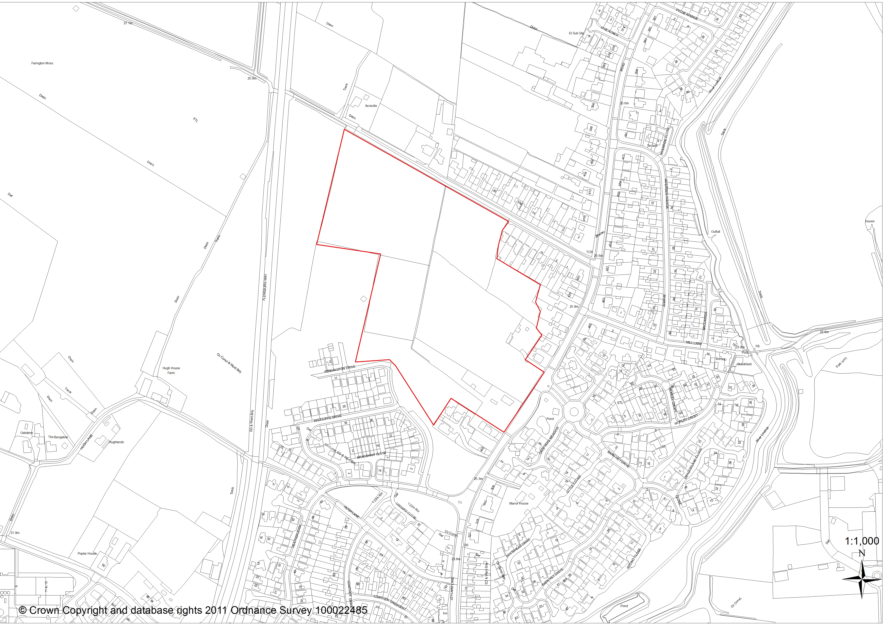

1. INTRODUCTION AND UPDATE
1.1 The application was presented to the Planning Committee at their meeting on the 29th May 2019 and was deferred to seek the submission of amended plans that remove all 2.5 storey housetypes, provides bungalows to the rear of properties on Bannister Lane and Croston Road and the ‘pepper-potting’ of the affordable housing.

1.2 In response to the reasons for deferral the applicant has provided amended plans along with additional supporting information. As a consequence of changes made to the housetypes the overall proposed number of dwellings has reduced from 175 dwellings to 174 dwellings, the density of the development has reduced from 26.92 dwellings per hectare to 26.76 dwellings per hectare and the on-site contribution of affordable housing as a percentage of the overall number of dwellings proposed has increased from 15.4% to 15.5%.

1.3 For each of the listed specific points raised by the Planning Committee the following has been provided:

Inclusion of 2.5 Storey Housetypes
  - The first reason for deferral sought the removal of all 2.5 storey housetypes from the
Proposed development. On this matter the applicant wishes to highlight that the Design Code for the wider section of the southern part of 'Site W' adopted by the Planning Committee at their meeting on the 13th March 2013 that supported the Masterplan indicated a mixture of 2, 2.5 and 3 storey dwellings on the section of the site subject to this application.

1.5 Below is an exert from the Design Code adopted by the Council in 2013, which was later submitted as a parameters plan and formed part of the associated outline planning consent:

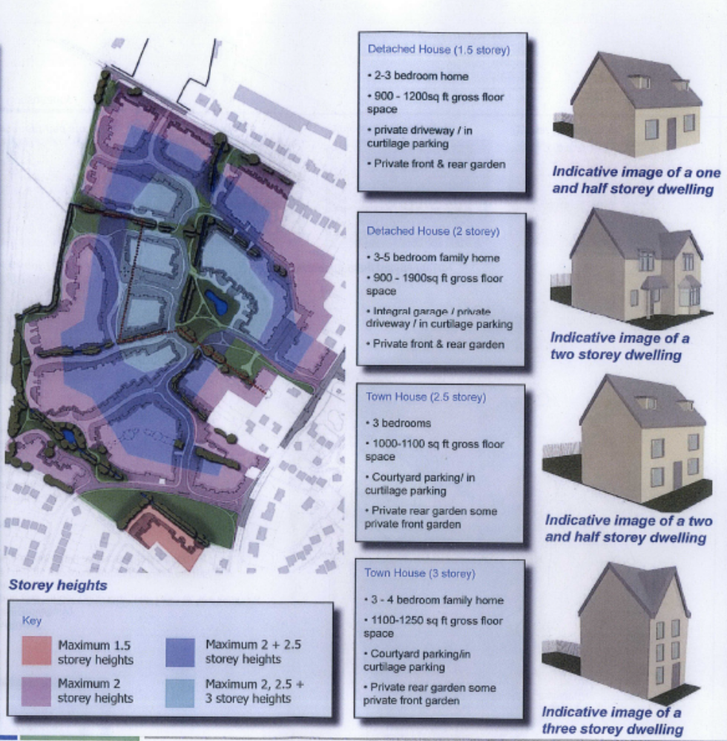

1.6 The applicant asserts that the proposed site layout previously presented to the Planning Committee was “completely in line with the parameters plan” and that “as the outline permission guides the reserved matters, it would be unreasonable to request the significant loss of 2.5 storey housing on the site”. Given the Design Code for the site that was approved in March 2013 and the parameters plan that was approved as part of the associated Outline planning consent in August 2013, which clearly establish the acceptance of 2.5 and 3 storey properties away from the site boundaries, Officers concur with this view. It is also important to consider that in March 2016 the Planning Committee did not raise issue with 2.5 storey properties forming part of the Miller Homes Reserved Matters submission on the site immediately to the south, with 25 properties that are 2.5 storey approved and currently being built.

1.7 Whilst being of the opinion that the proposal as previously submitted complied with the parameters set by the associated outline consent the applicant have made changes in response to the requests of the Planning Committee and local residents, namely:

- A reduction in the proposed number of 2.5 storey dwellings from 50 to 44 properties
- Revision of the site layout to reposition the distribution of 2.5 storey dwellings towards the centre of the site so that there is a progression in height from the perimeter of the site

1.8 In addition to the above the applicant also wishes to highlight the comments made by the Planning Inspector who presided the appeal for 261 dwellings by Permission Homes at Brindle Road, Bamber Bridge in December 2018, of which 83 dwellings were 2.5 storey high. The Inspector commented:

“The proposed development would include 2.5 storey housing. Although existing housing is predominantly 1, 1.5 and 2 storey in height, I saw several 2.5 storey houses on the recent development at Oak Leaf Drive, a short distance to the south-east. These buildings do not appear incongruous, but add an element of variety and interest to the local street scene.”

Provision of Bungalows
1.9 The second reason for deferral sought the provision of bungalows to the rear of properties on Bannister Lane and Croston Road. Again on this matter, the applicant wishes to highlight that the Design Code and parameters plan that were approved by the Planning Committee at two separate meetings in 2013 did not identify any dwellings less than 2 stories in height on this part of the wider southern part of ‘Site W’. However, in order to respond the Planning Committee and local residents, the applicant has included 6no. dormer bungalows on the site, to the rear of properties on Bannister Lane and partially along Croston Road.

1.10 The proposed dormer bungalows have roof eaves heights of 2.4m and roof ridge heights of 6.5m. By way of comparison the housetypes previously proposed where the dormer bungalows are now proposed had roof eave heights of 5.2m and roof ridge heights ranging from 7.8m-8.6m. No dormers windows or rooflights are proposed into the rear pitches of the roofs, resulting in the dormer bungalows being of the scale and appearance of true bungalows when viewed from existing opposing properties on Bannister Lane and, in part, along Croston Road.

1.11 As previously expressed by Officers the spatial separation for 2 storey properties to existing properties were met. The dormer bungalows proposed on Plots 14-19, with no first floor windows on the rear elevations and significantly lower roof ridge and eave heights, are considered to be acceptable and will not result in an undue impact on the amenities of neighbouring properties or the character and appearance of the area. It is the view of Officers that there is no sound reason to refuse the application in regards to the inter-relationship with existing residential properties or in relation to the number of bungalows proposed, dormer or otherwise.

Pepper-Potting of Affordable Housing
1.12 The final reason for deferral sought the 27 affordable housing units, which were clustered into 2 groups, be ‘pepper-potted’. In response to this request the applicant has made two changes. Firstly the housetypes of the affordable dwellings has been changed from affordable housetypes within the applicant’s design range to the Denton and Cedarwood housetypes which are market housing housetypes that are proposed elsewhere throughout the development. In that regard it will be impossible to differentiate between the market and affordable Denton and Cedarwood properties. Secondly, the applicant has dispersed the 27 affordable dwellings into 6 small clusters within the site.

1.13 It is the view of Officers that the changes made to the layout in relation to the ‘pepper-potting’ of affordable housing units and changes made to the housetypes to ensure that the affordable dwellings are indistinguishable from market housing, within the development, addresses this reason for deferral.

2. REPORT SUMMARY
2.1 The proposal is a Reserved Matters application for the erection of 174 dwellings on the site, 27 of which would be 'affordable houses' (in addition to a commuted sum of £950,000 to provide off-site affordable housing in the local area), with the matters of 'Appearance', 'Landscaping', 'Layout' and 'Scale' being applied for. The principle of the development on the site, together with the access, has been established by the previous outline approval.

2.2 The application relates to a 6.5 hectare parcel of land, in multiple ownerships, which is predominantly used for agriculture and abuts residential development. The site, which is irregular in shape and level, abuts Flensburg Way and a parcel of agricultural land to the west, residential properties on Croston Road to the east, a housing development under construction to the south and Bannister Lane and existing residential development to the north.

2.3 The proposed scheme reflects the character and appearance of the existing dwellings, with the proposal not considered to have a detrimental impact on the streetscene or the character of the area. The proposed scheme adheres to the agreed Design Code by including upgraded design of side elevations of properties and boundary treatments at prominent locations throughout the site. This includes the use of ‘living walls’ which are panels of greenery grown off-site and fitted to elevations of dwellings to provide an instant landscaping effect. A variety of surface materials are also proposed to create areas of differing character and interest.

2.4 Adhering to the 'green link' principle agreed as part of the adopted Masterplan for 'Site W' a 3m wide pedestrian/cycle way is proposed which, from the south, initially between an area of Public Open Space and the spine before diverting off through an area of Public Open Space located centrally within the site.

2.5 The proposed site layout provides 0.7 hectares of Public Open Space on site (which exceeds the 0.6 hectares required on site by way of a condition imposed on the wider outline approval) and accords with the requirements of Policy G10 of the South Ribble Local Plan 2012-2026. The proposed Public Open Space offered comprises of one large continuous landscaped area that runs centrally within the site from the southern boundary to the northern boundary and would tie in with an area of Public Open Space being provided in the Miller Homes scheme along its northern boundary together with a pocket of open space along the western boundary of the site.

2.6 One particular issue raised by neighbours is the use of Bannister Lane to serve 11 of the proposed dwellings via three shared driveways. The justification that supports that site specific policy relating to ‘Site W’ in the Local Plan (Policy C3) is clear in that “Bannister Lane shall not be used to provide a permanent primary or secondary vehicular access to the site so that the character and amenity of the Lane is maintained”. In the hierarchy of road types, driveways and shared driveways constitute tertiary access points, not primary or secondary access points, and therefore complying with the requirements of Policy C3. Furthermore County Highways have also advised that they have no objections from a highway/pedestrian safety perspective to Bannister Lane serving 11 of the proposed dwellings. Car parking standards have been assessed by County Highways and are policy compliant.

2.7 The outline permission included conditions relating to access, highway works, hours of construction, levels, noise management, foul and surface water drainage, tree protection, landscaping and ecology which do not need to be re-imposed as part of the Reserved Matters approval.

2.8 The proposed residential development is deemed to be in accordance with Policies 1, 3, 4, 5, 6 and 17 of the Core Strategy and Policies C3, G10 and G17 of the South Ribble Local Plan 2012-2026. For these reasons, and those contained within the report, the application is recommended for approval.

3. APPLICATION SITE AND SURROUNDING AREA
3.1 The application relates to a 6.5 hectare parcel of land, in multiple ownerships, which is predominantly used for agriculture and abuts residential development. The site, which is irregular in shape and level, abuts Flensburg Way and a parcel of agricultural land to the west, residential properties on Croston Road to the east, a housing development under construction to the south and Bannister Lane and existing residential development to the north.

3.2 The residential development currently under construction to the south (by Miller Homes) comprises of 175 dwellings and includes a section of spine road leading from Beconsaw Drive (formerly the section of Heatherleigh that joined with Croston Road) to the southern boundary of the application site that is being considered.

3.3 Residential development to the east of the site along Croston Road comprises predominantly of traditional detached two-storey properties within the modern Barn Hey Drive residential development present to the east of Croston Road.

3.4 Residential development along Bannister Lane comprises of a mixture of detached and semi-detached two-storey dwellings together with bungalows/dormer bungalows.

3.5 The site forms part of 'Site W' in the South Ribble Local Plan and is allocated as a 'Major Site for Development' under Policy C3.

4. SITE HISTORY
4.1 In August 2013 outline planning permission together with the matter of ‘Access’ (07/2012/0627/ORM) was granted for up to 350 dwellings on the wider section of the southern part of 'Site W' on the land between Bannister Lane and Heatherleigh. The application under consideration equates to approximately half of this wider outline permission. The Section 106 Agreement associated with this consent stipulates that in order to meet the policy requirement of 30% affordable housing, 15% is to be provided on-site together with a financial sum to the Council in lieu of the remaining 15% which is to be spent on the delivery of affordable units in the local area.

4.2 In May 2014 planning permission was granted in outline, together with the matter of ‘Access’ for up to 125 dwellings on an area land within ‘Site W’ immediately to the north of Bannister Lane (07/2014/0160/ORM). This permission, for which Wainhomes were the applicant, permitted the use of Bannister Lane to serve the development for a temporary period of time up until the section of spine road through the land to the north up to the Flensberg Way roundabout was constructed with discussions taking place at the time to secure the early implementation of the spine road delivery.

4.3 In December 2014 Reserved Matters approval (07/2014/0675/REM) was granted for 122 dwellings on the land subject to outline approval 07/2014/0160/ORM. This permission however has not been implemented and, along with the associated outline consent (07/2014/0160/ORM), has since expired. The consortium which formed the land subject to this application has since broken, with some land subsequently acquired by Homes England.

4.4 In March 2016, following lengthy negotiations relating to a Section 106 Agreement, planning permission was granted in outline, together with the matter of ‘Access’, for up to 400 dwellings on an area of land within ‘Site W’ under the control of Homes England 100m to the north of Bannister Lane up to the Flensburg Way roundabout (07/2014/0184/ORM). This permission remains extant.

5. PROPOSAL
5.1 The proposal is a Reserved Matters application for the erection of 174 dwellings on the site, 27 of which would be 'affordable houses', with the matters of 'Appearance', 'Landscaping', 'Layout' and 'Scale' being applied for.

5.2 The proposal comprises of a mixture of detached, semi-detached and terrace dormer bungalows, 2 and 2.5 storey dwellings together with an apartment building. In total 6 one-bed properties, 25 two-bed properties, 80 three-bed properties and 63 four-bed properties.

5.3 There is a diverse range of house types proposed both in terms of design and scale, with varying relationships. The proposed scheme includes upgraded design of side elevations of properties and boundary treatments at prominent locations throughout the site. A variety of surface materials are also proposed to create areas of differing character and interest. Following pre-application discussions throughout the site, where possible, plots have been sited away from the highway in order to provide an increase in green frontages.

5.4 The layout of the proposed scheme includes a continuation of the spine road being constructed within the Miller Homes site to the south to the northern boundary of the application site to the specification requested by County Highways. The spine road would form a cul-de-sac at its most northern point, to prevent access on to Bannister Lane, until the section of spine road within 'Site W' to the north of Bannister Lane is constructed from the Flensberg Way roundabout up to Bannister Lane. Following this the connection of the spine road across Bannister Lane would be made with a cul-de-sac head formed on Bannister Lane, just beyond 42 Bannister Lane, which would prevent access from the spine road onto Bannister Lane.

5.5 Adhering to the 'green link' principle agreed as part of the adopted Masterplan for 'Site W' a 3m wide pedestrian/cycle way is proposed which, from the south, initially between an area of Public Open Space and the spine before diverting off through an area of Public Open Space located centrally within the site. The 'green link' continues up to the boundary with Bannister Lane where highway improvement works to form a pavement along the southern side of Bannister Lane have already been secured as part of the associated outline consent. The 'green link' would then be picked up from the northern side of Bannister Lane as part of any development coming forward on the remainder of 'Site W'.

5.6 The proposed site layout provides 0.7 hectares of Public Open Space on site (which exceeds the 0.6 hectares required on site by way of a condition imposed on the wider outline approval) and accords with the requirements of Policy G10 of the South Ribble Local Plan 2012-2026. The proposed Public Open Space offering comprises of one large continuous landscaped area that runs centrally within the site from the southern boundary to the northern boundary and would tie in with an area of Public Open Space being provided in the Miller Homes scheme along its northern boundary together with a pocket of open space along the western boundary of the site.

5.7 Existing hedgerows are to be retained throughout the site where possible with supplementary landscaping also proposed.

5.8 The application is accompanied by a Design & Access Statement, Transport Statement, Land Contamination Report, Drainage Assessment, a Construction Noise Management Plan, an Ecology Assessment, an Air Quality Assessment and a Noise Impact Assessment.

5.9 Amended plans have been received in response to comments made by the Planning Committee and residents that led the deferral of the application in May 2019. These are outlined in the ‘Introduction and Update’ section of this report. Prior to this, in response to concerns raised by Officers and residents amended plans have were received that proposed changes to housetypes in the north-eastern corner of the site, where the site abuts existing residential development along Croston Road and Bannister Lane. The changes replaced 2.5 storey housetypes originally proposed abutting existing residential development with 2 storey housetypes. The width of the cul-de-sac spur off the proposed spine road which comprises of units 64-77 was also been widened from 4.5m to 5.5m so as to provide the required road specification should the parcel of ‘Site W’ to the west of the application site come forward.

6. REPRESENTATIONS
Letters of objection (25 in total) were received from 12 neighbouring properties in relation to the proposal as originally submitted. A summary of the points raised follows:

Character
- Proposed development would be out of character with the surrounding area
- Proposed development does not represent 'high quality'

Relationship To Neighbours
- Overlooking/loss of privacy and overshadowing/overdominance issues with proposed 2.5 storey dwellings in the north-eastern corner of the site specifically highlighted

Highway Issues
- Policy issue raised in regard to the use of Bannister Lane to serve 11 of the proposed dwellings by shared driveways
- Highway safety implications and congestion resulting from generation of additional traffic along Bannister Lane and the surrounding area
- Potential damage to existing highways by construction traffic with Bannister Lane not suitable for construction traffic

Drainage Issues
- Drainage issues leading to potential flooding

Ecology/Tree Issues
- Loss of agricultural land that is home to wildlife

Other Issues
- Capacity issues relating to utility services including household water supplies
- Noise and pollution associated with additional traffic
- Potential impact of neighbouring house prices
- Impact construction and associated traffic would have on residents in terms of noise
- Comments regarding the build quality of the applicant
- Ageing population would benefit from the provision of bungalows

A further 9 letters of objection were received following the submission of amended plans prior to the Planning Committee meeting on the 29th May 2019. A summary of the points raised follows:

Character
- Request that properties are replaced with bungalows.
- Separate respondent requests a bungalow to the rear of Marchacre Barn
- Lack of character in design proposals
Relationship To Neighbours
- Loss of light and view of skyline from existing properties
- Loss of privacy worsened by amended layout
Highway Issues
- Existing issues of double parking on Bannister Lane
Ecology/Tree Issues
- Request to retain existing trees as a ‘natural wildlife barrier’
- Impact on wildlife
- Potential impact on hedge roots

Other Issues
- Promise that there would be no access from Bannister Lane
- Respondent suggests that part of the site encroaches onto his land
- Loss of property value
- Boundary maintenance issues

As of the 11th June a further 3 letters of objection have been received following the submission of the most recent set of amended plans. A summary of the points raised follows:

Policy Issues
- Need for increased greenspace

Character
- Proposed development would be out of character with the surrounding area

Highway Issues
- Policy issue raised in regard to the use of Bannister Lane to serve 11 of the proposed dwellings by shared driveways
- Highway safety implications and congestion resulting from generation of additional traffic along Bannister Lane and the surrounding area

Other Issues
- Noise and pollution associated with additional traffic

7. CONSULTATION REPLIES

County Highways have raised no objections to the principle of the development, with the matter of ‘Access’ previously agreed for a development of up to 350 dwellings on the wider site. In assessing the current plans County Highways have also advised that they have no objections from a highway/pedestrian safety perspective to Bannister Lane serving 11 of the proposed dwellings with the wider associated outline planning consent having a condition which requires carriageway widening and the provision of a footpath along the section of Bannister Lane which the application site abuts.

With regards to the detailed submission County Highways have requested amended plans to address issues raised in regards to the provision of service verges, footpaths, pedestrian linkage, car parking provision, road widths and access arrangements. Amended plans have been provided which County Highways have confirmed address all matters.

Environmental Health have advised that with suitable noise mitigation, in the form of a 2m high acoustic fence along the western boundary of the site, and securing suitable glazing and ventilation specifications on the properties they have no objections to the proposal. A list of conditions that Environmental Health recommended be imposed includes a numbers of conditions that would duplicate conditions already present on the associated outline planning consent or are not a policy requirement. Conditions however recommended in relation to ground remediation works within Plots 9 and 10 and the provision of electric vehicle charging points can however be included, with the exception of the 6 unit apartment where the shared provision of such a facility would cause a management issue with the affordable housing association.

The Local Lead Flood Authority (LCC) have raised no objections to the proposal recommending standard conditions relating to surface water drainage, the SUDs and the agreement of a Surface Water Lifetime Management and Maintenance Plan.

United Utilities have commented that the submitted drainage design drawing is acceptable in principle and have raised no objections to the proposal subject to the imposition of standard conditions relating to drainage.

Ecology have advised that they are satisfied with the submitted ecology report which has been compiled by a competent ecologist. The survey noted that there is some ecological interest in trees and hedgerow to be retained on site. Proposed non-ornamental planting would offer biodiversity betterment and the maintenance plan supplied is considered acceptable. Suggested enhancement measures i.e. bat and bird box installation is welcomed although roosting opportunities are relatively low in number. Precautionary conditions relating to nesting birds and works in accordance with the surveys recommendations are requested. In addition a condition to seek pre-commencement submission of lighting detail in areas which might affect protected wildlife.

The Environment Agency have raised no objections to the proposal commenting that ecology buffer strips within the site are acceptable.

The Local Authority's Arboricultural Officer has raised no objections to the proposal recommending conditions relating to protective tree fencing, root protection and landscaping.

The Local Authority's Strategic Housing Officer has raised no objections to the proposal having considered the affordable housing provision and mix.

8. MATERIAL CONSIDERATIONS
8.1 The principle of a residential development on the wider site for up to 350 dwellings (of which the application site covers half of the wider site area), together with the matter of ‘Access’, has previously been established by the granting of outline planning permission 07/2012/0627/ORM.

Policy Considerations

8.2 i) NPPF
7.2.1 The NPPF promotes a presumption in favour of sustainable development and supports sustainable economic development to deliver, amongst other things, homes.

8.3 ii) Core Strategy Policy Considerations
8.3.1 Policy 1 of the Core Strategy is entitled ‘Locating Growth’ and encourages the focussing of growth and investment in the Key Service Centres of Chorley and Leyland and the other main urban areas in South Ribble.

8.3.2 Policy 4: Housing Delivery seeks to ensure that sufficient housing land is identified over the 2010-2026 period.

8.3.3 Policy 5 of the Core Strategy covers Housing Density and states:

“The authorities will secure densities of development which are in keeping with local areas and which will have no detrimental impact on the amenity, character, appearance, distinctiveness and environmental quality of an area, consideration will also be given to making efficient use of land.”

8.3.4 Policy 6 of the Core Strategy covers Housing Quality and aims at improving the quality of housing. This is assessed in the following sections of the report.

8.3.5 Policy 7 of the Core Strategy relates to Affordable Housing and confirms a target of 30% affordable housing for housing developments of 15 dwellings or more.

8.3.6 Policy 17: Design of New Buildings expects the design and new buildings to take account of the character and appearance of the local area and effectively mirrors criterion in the South Ribble Local Plan Policy G17.

8.4 iii) Affordable Housing
8.4.1 Policy 7 of the Core Strategy is entitled Affordable Housing and states that a target of 30% affordable housing provision is to be sought on new housing schemes. The proposed scheme meets the requirements of Policy 7 and the associated Section 106 Agreement on the wider outline permission, in that 27 of the 175 dwellings proposed (15.5%) would be ‘affordable housing’ with a commuted sum (of £950,000) in lieu of the remaining 15% to be paid to provide off-site affordable housing in the local area. Of the 27 dwellings proposed on-site, the associated Section 106 Agreement requires 60% to be affordable or social rent and 40% to be Intermediate Housing.

8.4.2 In response to the Planning Committee’s request for the ‘pepper potting’ of affordable housing the applicant has made two changes. Firstly the housetypes of the affordable dwellings has been changed from affordable housetypes within the applicant’s design range to the Denton and Cedarwood housetypes which are market housing housetypes that are proposed elsewhere throughout the development. In that regard it will be impossible to differentiate between the market and affordable Denton and Cedarwood properties. Secondly, the applicant has dispersed the 27 affordable dwellings into 6 small clusters within the site.

8.4.3 It should also be considered that in a recent appeal decision in relation to a residential development on Brindle Road (Planning Inspectorate ref. APP/F2360/W/18/3198822) the Planning Inspector dismisses the need to ‘pepper pot’ affordable houses within a residential development and concluded that cluster of ‘tenure blind’ affordable housing adequately integrate within developments and allow for inclusive and mixed communities.

8.5 iv) Open Space
7.5.1 The proposed site layout provides 0.7 hectares of Public Open Space on site (which exceeds the 0.6 hectares required on site by way of a condition imposed on the wider outline approval) and accords with the requirements of Policy G10 of the South Ribble Local Plan 2012-2026. The proposed Public Open Space offering comprises of one large continuous landscaped area that runs centrally within the site from the southern boundary to the northern boundary and would tie in with an area of Public Open Space being provided in the Miller Homes scheme along its northern boundary together with a pocket of open space along the western boundary of the site.

8.6 CIL
7.6.1 The approval of the associated outline planning permission pre-dated the introduction of the Community Infrastructure Levy charging schedule and, as such, monies would not be required through CIL. A charging schedule mirroring CIL, and its financial requirements, was however built into the Section 106 Agreement which will contribute to infrastructure requirements contained within the Regulation 123 list, including proportionate contributions towards the A582 / B5253 dual carriageway improvements and other highways/transport measures. These monies would also contribute towards additional educational provision to serve the development.

8.7 Character and Design
8.7.1 Policy 17 of the Core Strategy expects new buildings to “take account of the character and appearance of the local area” with Policy G17 of the South Ribble Local Plan 2012-2026 requiring development not have a detrimental impact on “the existing building, neighbouring buildings or on the street scene by virtue of its design, height, scale, orientation, plot density, massing, proximity, use of materials”. In consideration of the above, the local distinctiveness and character of the local area have been assessed. The surrounding residential development comprises of properties of varying sizes, designs and ages with a mixture of traditional and modern detached properties along Croston Road, detached and semi-detached two-storey dwellings together with bungalows/dormer bungalows along Bannister Lane and a mixture of modern detached, semi-detached and terraced properties within the Miller Homes site immediately to the south. As a result, the proposed mixture of housetypes and designs on the site is not considered to be out of character with the surrounding area. A condition to require agreement of the proposed sample materials with the Local Planning Authority prior to the commencement of the development will allow the Local Planning Authority to control the materials to ensure they relate well to local area. Sufficient garden spaces are proposed for the dwellings.

8.7.2 The proposed development is not considered to result in the overdevelopment of the site. The proposed scheme is at a density of 26.76 dwellings per hectare, less than the 26.9 dwellings per hectare being built on the Miller Homes scheme immediately to the south and significantly less than the average density figure assumed at the examination into the CIL charging schedule. Whilst the existing development further south on Heatherleigh is at a slightly lower density, at 25 dwelling per hectare, Heatherleigh comprises entirely of large detached dwellings. The now expired Wainhomes planning permission that was approved on land to the north of Bannister Lane was at a density of 27.5 dwellings per hectare.

8.7.3 The proposed scheme adheres to the agreed Design Code by including upgraded design of side elevations of properties and boundary treatments at prominent locations throughout the site. This includes the use of ‘living walls’ which are panels of greenery grown off-site and fitted to elevations of dwellings to provide an instant landscaping effect. A variety of surface materials are also proposed to create areas of differing character and interest.

8.7.4 For the above reasons the proposed development is considered to comply with Core Strategy Policy 17 and Policy G17 of the South Ribble Local Plan 2012-2026.

8.8 Relationship To Neighbours
8.8.1 The South Ribble Residential Design SPD requires directly facing habitable room windows to be a minimum of 21m spatial separation from the same in any other property. The same document requires 13m separation between a habitable room window and any blank wall or gable. Whilst more attuned to residential extensions, the SPD also assists with the design of new-build residential developments (Para A4.1).

8.8.2 Eastern boundary: Proposed Plots 1 and 2 would indirectly face no: 1 Duttonfield Close across Croston Road at 30m separation. The side elevation of Plot 2 would face the gable wall to 448 Croston Road in the south at 33m, and plots 7-13 would back onto no’s 434-428 (evens) Croston Road at between 21m and 37m. The rear elevations of Plots 7 and 8 would face the rear of no: 434 with a distance of 21m to the conservatory on the rear elevation of 434 Croston Road. The rear elevation of Plot 14, a dormer bungalow with only groundfloor windows on the rear elevation, would face Marchacre Barn with a separation distance of 26m to an extension on the rear of Marchacre Barn. A distance of 33m would be present from the side gable of Plot 15, a dormer bungalow to an extension present on the rear of Schiehallion. Distances between 36.5m and 38m would be present between the rear elevations of the dormer bungalows on Plots 15-19 to properties to the rear on Bannister Lane. Only ground floor window are proposed on the rear elevations of these plots.

8.8.3 Southern boundary: The eastern gable of proposed Plot 174 would face the rear elevation to no: 448 at 21m distance, whilst Plots 159-173 would be between 24m and 33m from recently developed dwellings on Orchard Mews. Hedgerow and retained trees also offer screening to these properties. Rear elevations of Plot 117-119 and the gable of Plot 116 would face new dwellings on Pennington Drive at more than 33m away; similar landscaping also protects the occupants of these properties from any loss of privacy.

8.8.4 On the western side of the site but facing south are proposed Plots 68 and 88 (gable wall) and Plots 89-93 which would face partially constructed Orsdall Close properties at between 21m and 32m separation

8.8.5 Western boundary: The proposed side elevation of Plots 119 and 109 would indirectly face the rear elevations of partially constructed properties on Orsdall Close at between 13m and 19m, and whilst these Plots would have an angled relationship, orientation is such that loss of privacy to existing or future residents is considered unlikely. The side elevations of Plots 94 and 108 would benefit from 13m direct spatial separation to the side and rear elevations of Orsdall Close dwellings.

8.8.6 Plots 57, 67 and 73 (side elevation) and 64-66 and 68-72 (front) face a tract of land beyond which is the Flensburg Way bypass. Although there is no recorded permission for this section of the site, it does form part of the wider Site W development area. Spatial separation between future properties in this area would however be assessed if and when proposals are submitted.

8.8.7 Northern Boundary: Directly facing Bannister Lane are proposed Plots 34-39 and Plots 59-62. The front elevations of Plots 36-41, and 42-47, and gable walls to Plot 40 and 41 would face no’s 18A – 42 Bannister Lane across the road itself at between 29m and 33m. Plots 57-60 would face ‘Acreville’ (residential) at a similar distance. Existing and proposed hedgerow screening would further protect the occupants of these properties.

8.8.8 All properties around the site edges are two storey in height. With the separation distances proposed, which meet policy standards, the proposed dwellings will not unduly overlook, be overlooked by or result in any loss of privacy or general amenity to existing or approved but unconstructed properties which abut the site boundaries. Spatial separation both within and beyond the site is policy compliant.

8.8.9 Proposed inter-relationships either meet, in the case of 434 Croston Road, or exceeds in the case of the 13 other properties that back onto the site, recognised minimum spatial separation standards. The proposed inter-relationships with existing residential dwelling are policy compliant and are considered to be acceptable so as to prevent an undue loss of amenity.

8.9 Highway Issues
7.9.1 The principle of the development together with the matter of Access to serve up to 350 dwellings on the area of the wider site has already been established as part of the associated outline planning consent.

8.9.2 One particular issue raised by neighbours is the use of Bannister Lane to serve 11 of the proposed dwelling via three shared driveways. The justification that supports that site specific policy relating to ‘Site W’ in the Local Plan (Policy C3) is clear in that “Bannister Lane shall not be used to provide a permanent primary or secondary vehicular access to the site so that the character and amenity of the Lane is maintained”. In the hierarchy of road types, driveways and shared driveways constitute tertiary access points, not primary or secondary access points, and therefore complying with the requirements of Policy C3. Furthermore County Highways have also advised that they have no objections from a highway/pedestrian safety perspective to Bannister Lane serving 11 of the proposed dwellings

8.9.3 The proposed section of the link road which runs through the site accords to the construction standard for a Local Residential Distributor Road and incorporates a footpath / cycleway, in part along the link road, as part of a green link through the wider site.

8.9.4 Car parking standards have been assessed by County Highways and are policy compliant.

8.9.5 Concern has been by neighbours at the potential damage to existing highways by construction traffic with Bannister Lane not suitable for construction traffic. Any damage caused to the adopted highway by construction traffic would be a matter for County Highways as the Local Highway Authority. The applicant has offered assurance that Bannister Lane will not be used by any construction traffic to access the site, this can be secured as part of the agreement of a Construction Management Plan.

8.10 Tree Issues / Wildlife
7.10.1 The submitted Arboricultural Method Statement identifies 19 groups of trees and a further 37 individual trees within the site (107 in total) that are proposed to be removed. No trees within the site are protected by TPO and none of the trees are worthy of such protection. The majority of these are located along the line of ditches central within the site. A comprehensive landscape masterplan has been submitted which shows a net loss of 21 trees but an net gain of 74 linear metres of hedgerow planting including feature trees at prominent locations, screen planting along rear boundaries and ornamental trees along dwelling frontages. The Local Authority's Arboricultural Officer has raised no objections to the proposal recommending conditions relating to protective tree fencing, root protection and landscaping.

8.10.2 No ecological issues were raised during the outline planning application, with the previously submitted Ecology Report describing the site as consisting of “improved grassland, arable land and poor semi-improved grassland” with the majority of the site being of “low ecological interest”.

8.10.3 An update Ecology Report has been provided which does not identify any significant changes. Ecology have raised no objections to the proposal recommending conditions relating to restrictions on works during bird nesting season and the agreement of a lighting strategy with biodiversity in mind.

8.11 Drainage Issues
7.11.1 The potential for drainage issues leading to potential flooding is a concern of local residents. The scheme however has been designed to ensure that existing surface water run-off rates from the site are not exceeded post development through the use of a drainage strategy which include Sustainable Urban Drainage Systems and retention ponds. The proposals have been fully assessed by both the Local Lead Flood Authority (LCC) and United Utilities who have raised no objections to the proposal.

8.12 Other Issues
7.12.1 Concern has been raised at the potential for noise and pollution associated with additional traffic. In terms of noise the inter-relationships proposed between residential properties meet the adopted minimum spatial separation standards and examples of similar relationships are present throughout the Borough. The development will also include various measures with the aim to minimise pollution from the development including measures within the Travel Plan to promote sustainable modes of transport, the provision of electric vehicle recharge points on properties and energy efficiency measures incorporated on and within the properties.

8.12.2 Neighbours have objected to the impact construction and associated traffic would have on residents in terms of noise. It is standard for any such permission to include a number of conditions to safeguard the amenity of neighbouring residents, this would include restrictions on the hours that construction can take place and dust suppression measures.

8.12.3 Neighbours have raised concern at potential capacity issues relating to utility services including household water supplies. United Utilities have however fully assessed the proposal and raised no objections.

8.12.4 Comments have been made by neighbours highlighting that with an ageing population the development would benefit from the provision of true bungalows. Whilst the Local Authority is looking to address this recognised issue through the reviewing of the Local Plan there is however currently no policy requirement for a provision.

8.12.5 Concerns raised regarding potential impact on neighbouring house prices and about the reported build quality of the applicant are not material planning considerations and cannot be considered as such.

8.12.6 A boundary dispute had also been raised by a neighbouring property with the neighbour having since confirmed in writing that this issue has been addressed.

8. CONCLUSION
9.1 The proposed residential development comprising of 174 dwelling on the site, 27 of which would be ‘affordable houses’, is considered to be acceptable on the 6.5 hectare site. The proposed development is not considered to result in the overdevelopment of the site and is not considered to be out of character with the streetscene. The proposed development is not considered to have an undue impact on the amenities of neighbouring properties and there are no significant highway safety or amenity implications.

9.2 The outline permission included conditions relating to access, highway works, hours of construction, levels, noise management, foul and surface water drainage, tree protection, landscaping and ecology which do not need to be re-imposed as part of the Reserved Matters approval.

9.3 Site W, and this portion of it, are important contributions for South Ribble’s element for City Deal. The development not only provides a significant contribution to housing supply but will also deliver part of the spine road. Both are key outputs for City Deal.

9.4 The proposed residential development is deemed to be in accordance with Policies 1, 3, 4, 5, 6 and 17 of the Core Strategy and Policies C3, G10 and G17 of the South Ribble Local Plan 2012-2026. For these reasons, and those contained within the report, the application is recommended for approval.

RECOMMENDATION:

Approval with Conditions.

RECOMMENDED CONDITIONS:

1. The development hereby approved shall be begun before the expiration of 2 years from the date of this permission.

REASON: To comply with the requirements of Section 92 of the Town and Country Planning Act 1990

2. The development shall be carried out in accordance with the approved materials schedule detailed on the approved Drawing no. A827 03 G (Facing Materials Plan) unless otherwise agreed in writing with the Local Planning Authority.

REASON: To ensure the satisfactory detailed appearance of the development in accordance with Policy 17 in the Central Lancashire Core Strategy and Policy G17 in the South Ribble Local Plan 2012-2026.

3. All new dwellings are required to achieve a minimum Dwelling Emission Rate of 19% above 2013 Building Regulations.

REASON: Policy 27 of the Central Lancashire Core Strategy requires new dwellings to be built to Code for Sustainable Homes Level 4. However following the Deregulation Bill 2015 receiving Royal Ascent it is no longer possible to set conditions with requirements above a Code Level 4 equivalent. As Policy 27 is an adopted Policy it is still possible to secure energy efficiency reduction as part of new residential schemes in the interests of minimising the environmental impact of the development.

4. Prior to the commencement of the development details shall be submitted to and approved in writing by the Local Planning Authority demonstrating that each dwelling will meet the required Dwelling Emission Rate. The development thereafter shall be completed in accordance with the approved details.

REASON: Policy 27 of the Central Lancashire Core Strategy requires new dwellings to be built to Code for Sustainable Homes Level 4. However, following the Deregulation Bill 2015 receiving Royal Ascent it is no longer possible to set conditions with requirements above a Code Level 4 equivalent. As Policy 27 is an adopted Policy it is still possible to secure energy efficiency reductions as part of new residential schemes in the interests of minimising the environmental impact of the development. This needs to be provided prior to the commencement so is can be assured that the design meets the required dwelling emission rate

5. No dwelling hereby approved shall be occupied until a SAP assessment (Standard Assessment Procedure), or other alternative proof of compliance (which has been previously agreed in writing by the Local Planning Authority) such as an Energy Performance Certificate, has been submitted to and approved in writing by the Local Planning Authority demonstrating that the dwelling has achieved the required Dwelling Emission Rate.

REASON: Policy 27 of the Central Lancashire Core Strategy requires new dwellings to be built to Code for Sustainable Homes Level 4. However, following the Deregulation Bill 2015 receiving Royal Ascent it is no longer possible to set conditions with requirements above a Code Level 4 equivalent. As Policy 27 is an adopted Policy it is still possible to secure energy efficiency reductions as part of new residential schemes in the interests of minimising the environmental impact of the development.

6. Prior to the first occupation of any associated dwelling the parking courts and manoeuvring areas identified on Drawing No. A827 01 H (Planning Layout) shall be surfaced or paved in accordance with the details provided and prior to the first use of the respective residential unit the associated car parking space/s shall be marked out and retained for the parking of vehicles and they shall not be used for any other purpose.

REASON: To ensure the provision and retention of adequate on site parking facilities and in accordance with Policy 17 in the Central Lancashire Core Strategy and Policy F1 of the South Ribble Local Plan 2012-2026.

7. Nothwithstanding the provisions of the Town and Country Planning (General Development Procedure) (Amendment) (No2) (England) Order 2008, or any subsequent Orders or statutory provision re-enacting the provisions of these Orders, all garages shown on the approved plans shall be maintained as such and shall not be converted to or used for living accommodation without the prior written approval of the Local Planning Authority in consultation with the Highway Authority.

REASON: - In the interests of highway safety and other highway users in accordance with Policy 3 of the Core Strategy.

8. The proposed measures of enclosure shown on the approved Drawing no. A827 04 G (Means of Enclosure Plan) shall be erected prior to the first occupation of the associated dwelling and retained thereafter.

REASON: To ensure the provision and retention of adequate screening in the interest of amenity and to accord with Policy 17 of the Central Lancashire Core Strategy and Policy G17(a) in the South Ribble Local Plan 2012-2026.

9. Prior to occupation, a "lighting design strategy for biodiversity" for areas to be lit shall be submitted to and approved in writing by the local planning authority. The strategy shall:

a) identify those areas/features on site that are particularly sensitive for bats and that are likely to cause disturbance in or around their breeding sites and resting places or along important routes used to access key areas of their territory, for example, for foraging; and
b) show how and where external lighting will be installed (through the provision of appropriate lighting contour plans and technical specifications) so that it can be clearly demonstrated that areas to be lit will not disturb or prevent the above species using their territory or having access to their breeding sites and resting places.

All external lighting shall be installed in accordance with the specifications and locations set out in the strategy, and these shall be maintained thereafter in accordance with the strategy. Under no circumstances should any other external lighting be installed without the written agreement of the local planning authority.

REASON: To ensure that adequate provision is made for these protected species in accordance with Policy 22 in the Central Lancashire Core Strategy and Policy G16 in the South Ribble Local Plan 2012-2026

10. No dwelling hereby approved shall be occupied until the mitigation measures indicated within Chapter 5 of the approved ecological assessment (TER 7258.004 v1) have been implemented in full. These measures shall be retained within the development at all times thereafter.

REASON: To ensure that adequate provision is made for these protected species in accordance with Policy 22 in the Central Lancashire Core Strategy and Policy G16 in the South Ribble Local Plan 2012-2026

11. Prior to the occupation of Plots 41-93, details of an acoustic barrier to the western boundary comprising of a 2m acoustic fence, shall be submitted to and approved by the Local Planning Authority and the occupation of any dwelling shall not occur until the fencing has been erected in accordance with the approved details. The approved acoustic screen/fence shall be retained and maintained at all times thereafter.

REASON: To ensure the provision and retention of adequate screening in the interest of amenity and to accord with Policy 17 in the Central Lancashire Core Strategy

12. Details of the Plots, and windows within those plots, that are to be fitted with standard specification double glazed window units meeting a minimum value of Rw 30dB(A), incorporating acoustic trickle ventilation capable of providing the same level of attenuation as the closed window unit when in the open position, shall be submitted to and approved in writing by the Local Planning Authority prior to occupation. To prevent the need for a window to be opened to ventilate the property a positive input ventilation system shall be installed to each dwelling.

Reason: In the interests of the amenity of the nearby residents in accordance with Policy 17 & 28 of the Central Lancashire Core Strategy.

13. The development hereby approved shall be constructed to the highway layout detail shown as an insert referenced 'Access Road detail prior to future link across Bannister Lane' until the internal access road for the section of 'Site W' to the north of Bannister Lane is provided to the boundary of the application site and that access provides an unencumbered, unfettered access to the Flensburg Way/Penwortham Way roundabout. Bannister Lane will then be stopped up for vehicles with car turning facilities provided at the stopped up end and the connection made to the site to the north, as detailed in drawing number A827 01 H. This work shall be undertaken within 2 months of the unfettered access being provided and a stopping up order for Bannister Lane being executed.

REASON: In the interests of highways safety and highway amenity in accordance with Policy 3 of the Core Strategy and Policies C3 and G17 of the South Ribble Local Plan.

14. The development, hereby permitted, shall be carried out in accordance with the submitted approved plans numbered 410.05616.00008.1.0 Site Setting and Construction Phase Buffer Zones, 410.05616.00008.2.0 Modelled Road Links and Operational Phase Sensitive Receptors.mxd, 827_05 Site and Location Plan, 827_House Type Brochure 10.06.19, 827-01_H Planning layout, 827-02_H Coloured Layout, 827-03_G Facing materials plan, 827-04_G Means of enclosure plan, 827-06_E Massing plan, 827-07_E Occupancy, 827-08_E Parking Plan, 827-09_E Refuse Plan, 827-10_E Tenure Plan, 7115, SK01_C - Engineering Appraisal, 7115-SK02-1_B - Highway Longsections Sheet 1 of 2
7115-SK02-2_B - Highway Longsections Sheet 2 of 2, A827_02_B_Coloured Layout, A827_19_G_STREET SCENES A-E, G7258.001 Ecological Constraints Plan - OS Base, G7258.001 Ecological Constraints Plan, R-2184-1C Landscape Masterplan 500@A0, R-2184-2C Landscape Details 200@A1, R-2184-3BLandscape Details 200@A1, R-2184-4C Landscape Details 200@A1, R-2184-5B Landscape Details 200@A1, R-2184-6B, Landscape Details 200@A1, R-2184-7B Landscape Details 200@A1 and R-2184-8B Public Open Space Details various@A0.

REASON: To ensure a satisfactory standard of development in accordance with Policy 17 in the Central Lancashire Core Strategy and Policy G1 of the South Ribble Local Plan (2012-2026).

15. The remediation works identified within report D9230, Remediation Strategy, Dunelm Geotechnical & Environmental shall be followed to include the provision of 600mm of clean material to the rear gardens of Plots 9 and 10.

REASON: In the interests of the amenity and to safeguard the living conditions of the nearby residents in accordance with Policy 17 in the Central Lancashire Core Strategy and the NPPF.

16. Prior to the first occupation of any dwelling, excluding Plots 160-165, that dwelling shall be provided with a 13amp socket that can be upgraded to a fast electric vehicle charging point, which shall be retained for that purpose thereafter.

REASON: To enable and encourage the use of alternative fuel use for transport purposes in accordance with Policy 3 of the Central Lancashire Core Strategy.

RELEVANT POLICY

1 Locating Growth (Core Strategy Policy)

3 Travel (Core Strategy Policy)

4 Housing Delivery (Core Strategy Policy)

5 Housing Density (Core Strategy Policy)

6 Housing Quality (Core Strategy Policy)

17 Design of New Buildings (Core Strategy Policy)

POLC3 Land between Heatherleigh and Moss Lane, Farington Moss

POLG17 Design Criteria for New Development

Note:

